Chapter 1
INTRODUCTION
- Brief history of SILENT WRITER
In today’s learning environments, students are often distracted by ambient noise in libraries, classrooms, hostels, and public study spaces. While earplugs are an effective non-digital solution for noise reduction, they are frequently misplaced, unhygienic to carry loosely, or forgotten altogether.

Silent Writer is an innovative stationery product that integrates safe storage of non-digital earplugs within a pen, ensuring that students always have access to noise-blocking support while studying. This simple yet effective design promotes concentration, portability, and hygiene without relying on electronic components.

Chapter 2
Problem Statement
2.1 Description

Students often face difficulty concentrating due to:
Environmental noise
Lack of portable noise-reduction tools
Misplacement or unhygienic storage of earplugs
Dependence on electronic devices
Carrying earplugs separately is inconvenient and reduces the likelihood of regular use.

2.2 Challenge Statement
Designing a writing instrument that can safely store non-digital earplugs without sacrificing the pen's usability, comfort, or appearance is the main challenge. In addition to being lightweight and portable for regular student use, the product must guarantee hygienic storage, easy accessibility, and durability. The solution should also be affordable, eco-friendly, and able to be produced in large quantities so that it can be widely used in educational settings. Developing a straightforward, non-electronic design that efficiently facilitates concentrated study without adding distractions or maintenance needs is another challenge.

Chapter 3
3.1 Design Thinking Process
- Empathize: Interviews with 30+ students, 7 faculty, and 3 administrators revealed delays, failed scans, and mismatches.
- Define: Key needs identified: faster scanning, offline capability, reliable syncing, real‑time visibility.
- Ideate: Generated 10+ ideas. Final solution selected: biometric + IoT device with dashboard.
- Prototype: A hardware prototype with fingerprint sensor, microcontroller, and IoT connectivity was developed.
- Test: Testing reduced queue time from 10 minutes to ~1 minute with 100% accuracy during trials
3.2 Methodology
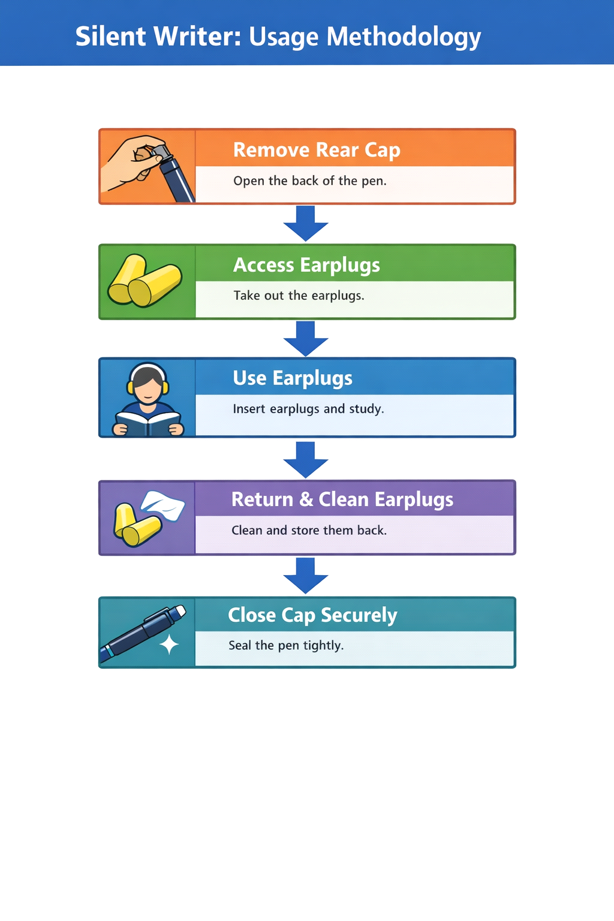

3.3 Prototype Description
3.3.1 Materials Used
- White Board Marker
- Non Digital Earplugs (NOISE CANCELLATION)
- Coping Saw
- Hot Glue

3.3.2 System Diagram

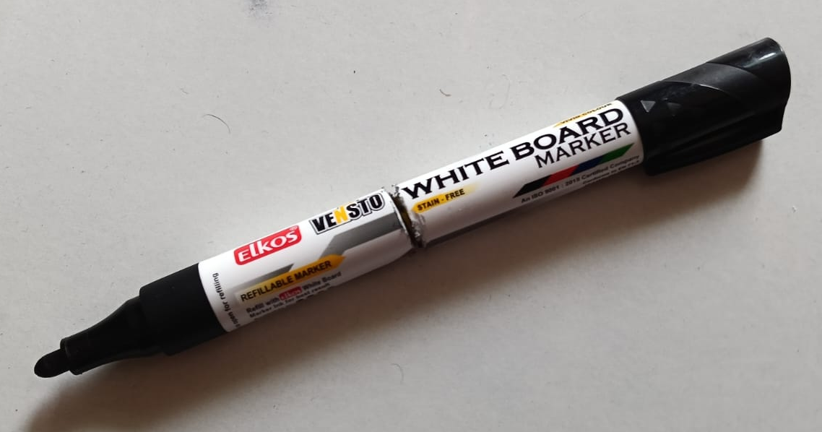
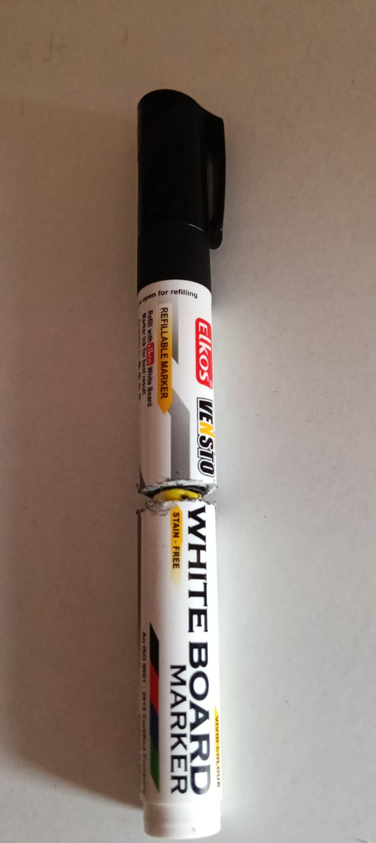
Chapter 4
Results and Analysis
User Testing & Feedback
Sample:
Participants:
- 10 students
Observations:
- Reduced distraction in noisy environments
- Increased likelihood of earplug usage
- Easy integration into daily study habits
Feedback:
- “I don’t forget my earplugs anymore.”
- “Simple idea but very useful.”
- “Feels like a normal pen.”

Chapter 5
Conclusion & Future Work
Conclusion
- Silent Writer successfully combines stationery and study wellness into a single product. By integrating non-digital earplug storage into a pen, it provides a cost-effective, portable, and hygienic solution for improving concentration without technological dependence.

Future Work

- Antimicrobial coating inside storage chamber
- Multiple earplug size variants
- Sustainable eco-friendly materials
- Custom branding for institutions

References
Online articles
- https://chatgpt.com/

Team Roles

- Team leader:
Bhavana: Led the team and coordinated tasks
- Suhas - Worked on pen design and electronics
- Prem and Shanmukh - Documentation and content prepared docs, reports and presentation slides
- Avani - Research and testing based on pen looks and challenges identified

